url-patterns

What is url-pattern?
Views are server side programs and these programs are called from browser using a public name called url-pattern.
Views are private resources and these resources cannot accessible from browser directly.
Mapping of view with public name is called url-mapping
Server always search for url-pattern the order in which is defined inside urls.py (url configuration file).

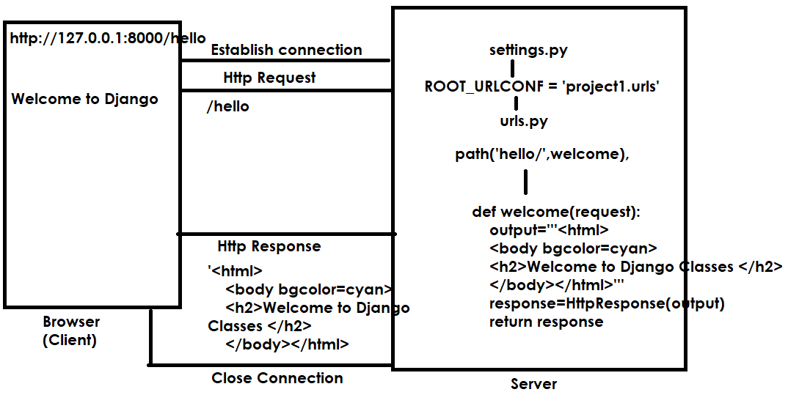

How to define url-patterns?
url-patterns are defined using functions provided by django.urls module.
- path()
- re_path()

path() : This function is used to define url-pattern
Syntax: path(‘url-pattern’,view-name)
re_path(): This function is used to define url-pattern using regular expression
syntax: re_path(r’pattern’,view-name)

urls.py
from django.contrib import admin
from django.urls import path,re_path
from app1.views import welcome,find_server_time
urlpatterns = [
path('admin/', admin.site.urls),
re_path(r'^h.a/',welcome),
path('hello/',find_server_time)
]

url configuration can be done at,
- application level
- project level
if project is having multiple applications and defining all urls of multiple applications at project level identifying becomes complex.
To avoid this complexity define urls at application level and include at project level.

Create django project with multiple applications

PS C:\Users\Satish Gupta> cd D:\Backup\Django9amMar
PS D:\Backup\Django9amMar> django-admin startproject project2
PS D:\Backup\Django9amMar> cd project2
PS D:\Backup\Django9amMar\project2> python manage.py startapp app1
PS D:\Backup\Django9amMar\project2> python manage.py startapp app2
PS D:\Backup\Django9amMar\project2> python manage.py startapp app3
PS D:\Backup\Django9amMar\project2>

Inside app1 (views.py)

from django.shortcuts import render
from django.http import HttpResponse
# Create your views here.

def view1(request):
response=HttpResponse("<h1>Response from View1 of App1</h1>")
return response
def view2(request):
response=HttpResponse("<h1>Response from View2 of App1</h1>")
return response

inside app1 (urls.py create this module)
from django.urls import path
from app1.views import view1,view2
urlpatterns=[path('v1/',view1),
path('v2/',view2),

]

Inside app2 (views.py)
from django.shortcuts import render
from django.http import HttpResponse
# Create your views here.
def view1(request):
response=HttpResponse("<h1>Response from View1 of App2</h1>")
return response
def view2(request):
response=HttpResponse("<h1>Response from View2 of App2</h1>")
return response

inside app2 (urls.py create this module)
from django.urls import path
from app2.views import view1,view2
urlpatterns=[path('v1/',view1),
path('v2/',view2),

]

inside app3 (views.py)
from django.shortcuts import render
from django.http import HttpResponse
# Create your views here.

def view1(request):
response=HttpResponse("<h1>Response from View1 of App3</h1>")
return response
def view2(request):
response=HttpResponse("<h1>Response from View2 of App3</h1>")
return response

inside app3 (urls.py create this module)
from django.urls import path
from app3.views import view1,view2
urlpatterns=[path('v1/',view1),
path('v2/',view2),

]

Inside urls.py (project level)
from django.contrib import admin
from django.urls import path,include

urlpatterns = [
path('admin/', admin.site.urls),
path('app1/',include('app1.urls')),
path('app2/',include('app2.urls')),
path('app3/',include('app3.urls')),
]

Install applications (settings.py)
INSTALLED_APPS = [
'django.contrib.admin',
'django.contrib.auth',
'django.contrib.contenttypes',
'django.contrib.sessions',
'django.contrib.messages',
'django.contrib.staticfiles',
'app1',
'app2',
'app3',
]

PS D:\Backup\Django9amMar\project2> python manage.py runserver
include() function
include() is predefined function of django.urls module
this function is used to include url-pattern defined inside another file(module).

Syntax: path(‘path’,include(‘application-name.urls’))

